**NAME: P V NAVI KISHORE**

**REG.NO.: 192111220**

**CODE: CSA0734**

**EXPERIMENT:39**

**AIM:**To impement sliding window protocol

**PROGRAM:**

int main()

{

int w,i,f,frames[50];

printf("Enter window size: ");

scanf("%d",&w);

printf("\nEnter number of frames to transmit: ");

scanf("%d",&f);

printf("\nEnter %d frames: ",f);

for(i=1;i<=f;i++)

scanf("%d",&frames[i]);

printf("\nWith sliding window protocol the frames will be sent in the following manner (assuming no corruption of frames)\n\n");

printf("After sending %d frames at each stage sender waits for acknowledgement sent by the receiver\n\n",w);

for(i=1;i<=f;i++)

{

if(i%w==0)

{

printf("%d\n",frames[i]);

printf("Acknowledgement of above frames sent is received by sender\n\n");

}

else

printf("%d ",frames[i]);

}

if(f%w!=0)

printf("\nAcknowledgement of above frames sent is received by sender\n");

return 0;

}

**OUTPUT:**

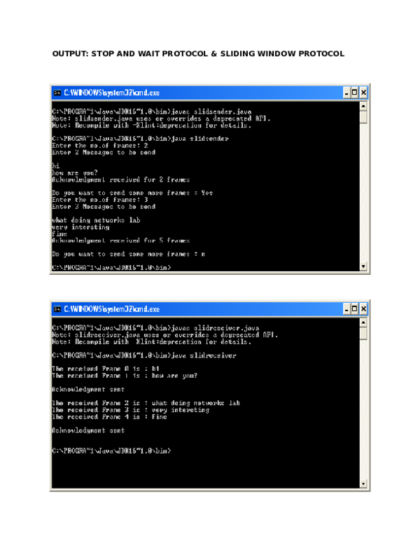

**RESULT:** Therefore, implementation of sliding window protocol has been successfully excecuted.